Excerpt on Direct Climate Cooling Governance and Coordination

Table 1: Typology of Approaches to Direct Climate Cooling (DCC), Table 2: Description of Direct Climate Cooling Approaches, and Section 6: Challenges and Opportunities from: Addressing the Urgent Need for Direct Climate Cooling: Rationale and Options, Oxford Open Climate Change 2024 forthcoming. Aug. 17, 2024, preprint.

Ron Baiman¹, Sev Clarke², Clive Elsworth³, Leslie Field⁴, Michael MacCracken⁵, John Macdonald⁶, David Mitchell⁷, Franz Dietrich Oeste⁸, Suzanne Reed⁹, Stephen Salter¹⁰, Herb Simmens¹¹, Ye Tao¹², Robert Tulip¹³

¹ Benedictine University, Lisle, IL 60532, USA, and Healthy Planet Action Coalition, Los Osos, CA 93402, USA
² Winwick Business Solutions P/L, Mount Macedon, Victoria 3441, Australia
³ Climate Arks Ltd., London, England EC1V 2NX, UK
⁴ Bright Ice Initiative, Portola Valley, CA 94028, USA
⁵ Climate Institute, Washington, DC 20001, USA, and Healthy Planet Action Coalition, Los Osos, CA 93402, USA
⁶ Rebrighten.org, Seattle, WA 98104, USA
⁷ Desert Research Institute, Reno, NV 89512, USA
⁸ gM-Ingenieurbüro, Kirchhain 35274, Germany
⁹ The Collaboration Connection, West Sacremento, CA 95605, USA, and Healthy Planet Action Coalition, Los Osos, CA 93402, USA
¹⁰ University of Edinburgh, Edinburgh, Scotland EH8 9YL, UK
¹¹ Planetphilia, Silver Spring, MD 20910, USA
¹² MEER (Mirrors for Earth’s Energy Rebalancing), Calabasaas, CA 91302, USA
¹³ Rebrighten.org, Seattle, WA 98104, USA, and Healthy Planet Action Coalition, Los Osos, CA 93402, USA
Corresponding author: Benedictine University, USA, Email: rbaiman@ben.edu

Table 1: Typology of Approaches to Direct Climate Cooling (DCC)

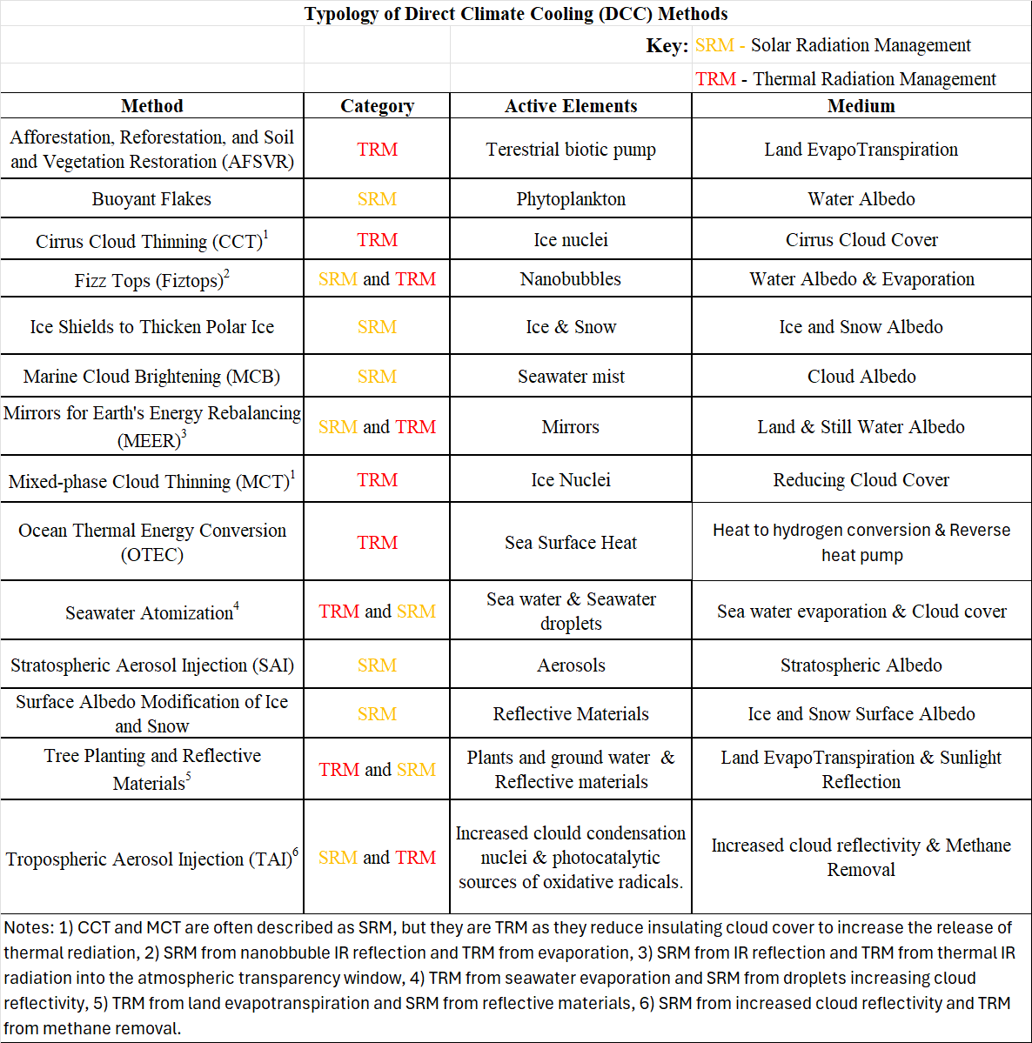

Table 2: Description of Direct Climate Cooling (DCC) Approaches 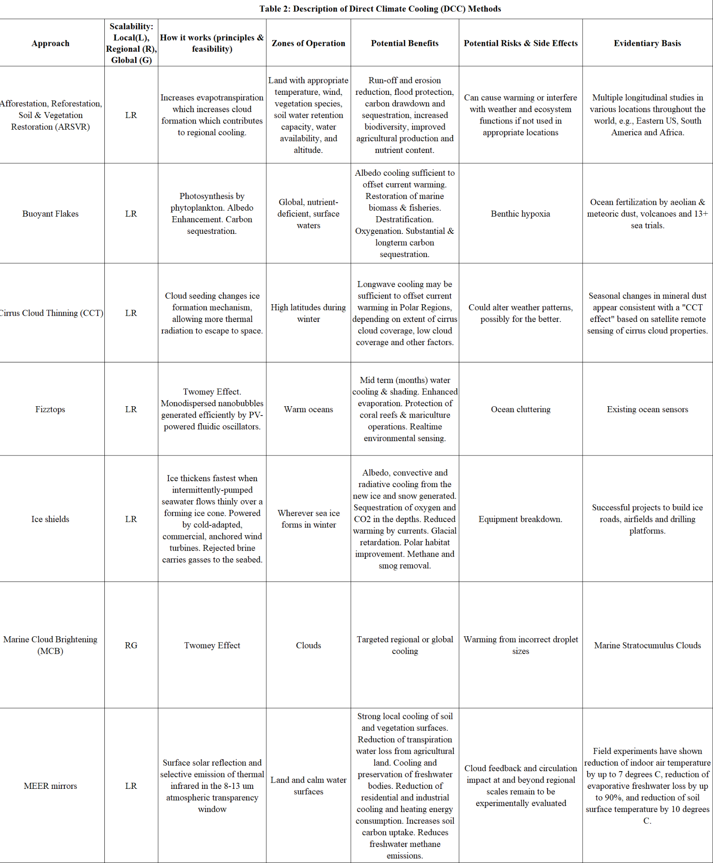
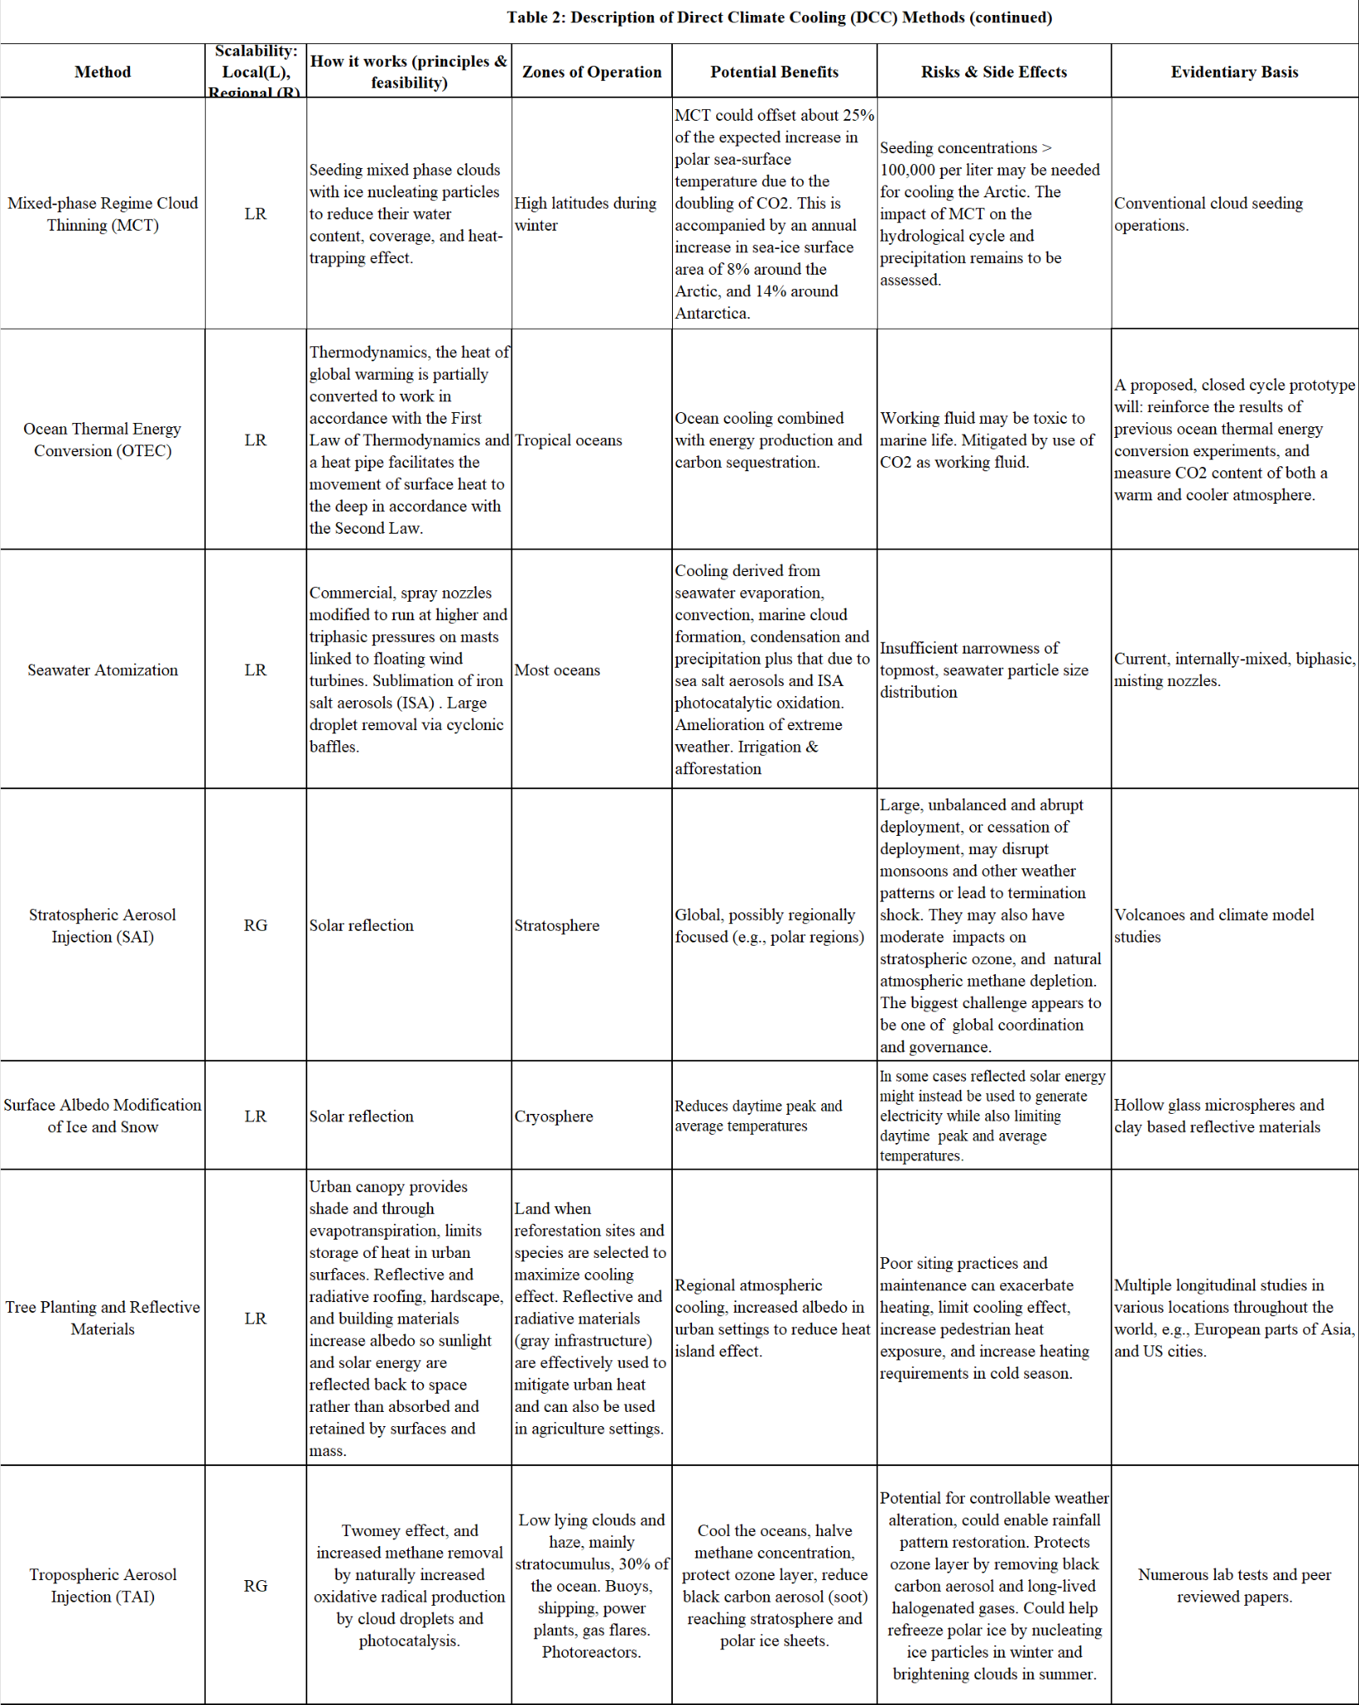
Note: Column headings from left to right refer to: a) name of the DCC approach, b) its potential near-term scalability or level of cooling impact, c) summary technological description of how the method would potentially work, d) where it would likely be most effective, e) its possible risks and side effects and f) current evidence for its DCC potential.

6. Challenges and Opportunities

With global warming near to exceeding the 1.5°C Paris Agreement target, there is a clear, urgent need to find approaches that could, if implemented, exert near-term cooling influences around the globe. We mean that within a decade, commitment to research and initiate deployment of such interventions must be incorporated into the Conference of the Parties policies and agreements if we hope to stabilize global temperatures and avert the most catastrophic climate change impacts.

The set of Direct Climate Cooling (DCC) approaches presented in Table 2 reflects the authors’ assessment of initially researched approaches that, appropriately deployed in the near-term, could be used to exert a local, regional, or global cooling influence. DCC methods designated as RG could be deployed to have ‘medium to large leverage’ as their influences would be broadly exerted in the stratosphere or via the troposphere’s clouds and winds. DCC methods designated as LR could be deployed to have ‘small to medium leverage’ as their influences would be generally confined to local or regional areas. Taken together, the approaches presented here exhibit a range of characteristics (e.g., low-leverage to high-leverage; low to higher cost; rapidly scalable to global scales or not; with or without major co-benefits; most useful at local to global scales; already initially deployed to only minimally researched; etc.). Here we simply present possibilities, leaving to further research and consideration which ones, deployed singly or together with others, would best be deployed as part of an integrated approach to complement the emissions reduction and removal and abate the intensifying climate emergency.

As indicated throughout Sections 1-5, and in view of the high likelihood that GHG emissions reduction and removal will not limit temperature rise and associated climate change impacts in this century, we argue that not trying to deploy DCC is the ‘moral hazard’ now confronting humanity. We acknowledge that the potential for unintended consequences merits attention and that further research and establishment of a governance structure are needed [144,219]. Our position is that the need for DCC is urgent and must immediately begin to be met.

Waiting until full governance is wholly in place to begin climate intervention will be too late. Delays in establishing critical globally agreed upon deployment protocols may lead to abrupt, unilateral, unjust, and/or non-transparent deployments of very high-leverage DCC methods by individual countries or coalitions to benefit themselves. Such actions could cause serious political or economic tensions and conflicts with powerful actors who do not judge the deployment to be in their own best interest [220]. We believe that in many cases national and local jurisdictions can apply protocols that enable transparent research and pilot testing to be conducted and establish a process for responsibly scaling up deployment to local and regional levels within their jurisdictions. For these and other reasons we do not believe it is necessary or prudent to restrict current DCC efforts to research and localized field trials, as proposed in many of the documents supporting DCC research [81–83,85,87,88].

As discussed in the DCC method summaries, several DCC methods can be applied at local scale to exert a cooling influence and provide other benefits at little to no risk. Some regional scale efforts seem unlikely to have significant “cross- boundary” impacts. For example, the ongoing efforts to “save the Great Barrier Reef” using MCB seem unlikely to have long-term effects [142,221]. These applications are of short duration and mainly targeted at limiting extreme ocean heating events. The gyre pattern of ocean currents around the Great Barrier Reef would also limit potential “cross-boundary” impact [142,221] It may also be possible to coordinate regional DCC interventions that could have ‘cross-boundary’ impacts by building upon current bilateral or regional legal frameworks that address concerns arising from “cloud seeding” that enhances precipitation in some locations but might increase harmful climate outcomes in others [222].
Climate interventions that are more likely to cross national boundaries pose a greater challenge [223]. But again, scaling DCC methods like MCB for regional application may be more easily coordinated across national boundaries than current common geophysical engineering projects such as building a dam on a major river that blocks or reduces the flow of water downstream.

It may be possible to pilot-test and gradually deploy high-leverage DCC methods, like SAI, at a regional scale without global governance and coordination by following the Great Barrier Reef MCB example. SAI could be pilot tested with consent from affected communities and authorities in accordance with an international, voluntary and transparent ‘coalition of the willing’ agreement. If successful, such an endeavor could build global trust and confidence in the same way as the international space station has done [224].

In some cases, sufficient authority to deploy a cooling mechanism may already be in place. The International Maritime Organization (IMO) could, for example, address the unintended global warming produced by its (well-intended to protect human health) maritime fuel sulfate content restrictions, under its existing authority [2,23,225]. First, it could immediately adopt an emergency regulation relaxing 2015 and 2020 shipping fuel sulfate content restrictions in the “high seas”. The intent would be to resume sulfate aerosol cooling over the high seas while avoiding significant human health impacts on coastal and island populations. Second, as a long-term solution, the IMO could support research and implement regulations requiring use of alternative fuels or power sources (see section 5) and the emission of aerosol precursors more benign than sulfates to human and environmental health, to replace the prior beneficial global cooling from using fossil fuels [23]. As noted in section 1, these measures alone could produce significant, urgently needed, DCC.

It is unlikely that high-leverage regional and global scale DCC methods could be effectively weaponized, as has been hypothesized by some [220,226]. The DCC method that is most often discussed in this context is SAI. However, modeling indicates that SAI could not be specifically targeted over nation states with reasonable accuracy. Although it might be possible to influence some geographic and seasonal variations in precipitation with carefully modulated SAI deployments, latitudinal and longitudinal mixing in the stratosphere make geographically specific outcomes exceedingly difficult, if not impossible [227,228]. It appears that only general latitudinal targeting is possible with SAI. That is why polar SAI deployment in the spring has been proposed as the most practical and efficient way to pilot regional-scale SAI efforts to produce summer polar cooling [16,229].

An additional practical impediment to weaponized deployment of SAI is that only a small number of countries either have, or have the capability to develop, aircraft that could loft the large payloads necessary for an effective SAI program, and the military propulsion technology necessary for this is not available for sale or purchase without at least tacit acquiescence by nations that have this technology such as the US, UK, EU and possibly a few others [228,230]. Also, it appears that only one country, the US, currently has aircraft that can loft large enough payloads to the stratosphere to initiate an effective pilot SAI program, though new customized planes would need to be developed to do this efficiently over a long period [177,228]. The US SABRE (Stratospheric Aerosol processes, Budget, and Radiative Effects) program is in fact currently using two high-altitude research aircraft that can loft payloads into the stratosphere, equipped with sampling instruments, to measure the properties of aerosols in the upper troposphere and lower stratosphere [231,232].

Finally, as with much of modern infrastructure, it might be possible to interrupt an SAI program by sabotaging its infrastructure or supply chain in hopes of ending the deployment. However, it is hard to understand what the incentive for this would be given the “shockingly strongly favorable” results from roughly a hundred studies that suggest pervasively beneficial impacts of SAI [18]. And, as with other critical infrastructure, this risk, and the possible “termination shock” risk that could result from an abrupt and complete cessation over an extended time, could be significantly reduced through redundancy and protective measures that make it more unlikely.

The ultimate goal and need is to develop comprehensive DCC governance and coordination for DCC efforts with significant cross-regional or global impact. Both implicit and explicit global coordination governance regimes are likely to evolve over time as the scale of DCC deployment grows larger. Building global, public, and political trust and confidence through gradual, local, and regional pilot testing of potential DCC efforts is critical to the development of comprehensive DCC global coordination and governance frameworks. Pilot testing and “learning by doing” to complement continued research will enable a fuller understanding of the potential impacts, positive and negative and near- and long-term, of large-scale DCC.

References

1. UNITED NATIONS FRAMEWORK CONVENTION ON CLIMATE CHANGE. 1992.
2. Hansen JE, Sato M, Simons L et al. Global Warming in the pipeline. Oxford Open Climate Change 2023;3:kgad008.
3. Climate Change 2022, Mitigation of Climate Change. Summary for Policymakers.
4. Tracking emissions by country and sector. Brookings 2022.
5. Global climate summary for January 2024 | NOAA Climate.gov. 2024.
6. Change NGC. Global Surface Temperature | NASA Global Climate Change. Climate Change: Vital Signs of the Planet.
7. Global Climate Highlights | Copernicus.
8. Smith AB. U.S. Billion-dollar Weather and Climate Disasters, 1980 - present (NCEI Accession 0209268). 2020, DOI: 10.25921/STKW-7W73.
9. Armstrong McKay DI, Staal A, Abrams JF et al. Exceeding 1.5°C global warming could trigger multiple climate tipping points. Science 2022;377:eabn7950.
10. Lenton TM, Rockström J, Gaffney O et al. Climate tipping points — too risky to bet against. Nature 2019;575:592–5.
11. Baiman R. In Support of a Renewable Energy and Materials Economy: A Global Green New Deal That Includes Arctic Sea Ice Triage and Carbon Cycle Restoration. Review of Radical Political Economics 2021;53:611–22.
12. Biermann F, Oomen J, Gupta A et al. Solar geoengineering: The case for an international non‐use agreement. WIREs Climate Change 2022;13:e754.
13. Diamond MS, Gettelman A, Lebsock MD et al. To assess marine cloud brightening’s technical feasibility, we need to know what to study—and when to stop. Proc Natl Acad Sci USA 2022;119:e2118379119.
14. Jebari J, Táíwò OO, Andrews TM et al. From moral hazard to risk-response feedback. Climate Risk Management 2021;33:100324.
15. McLaren D. Mitigation deterrence and the “moral hazard” of solar radiation management. Earth’s Future 2016;4:596–602.
16. MacMartin DG, Visioni D, Kravitz B et al. Scenarios for modeling solar radiation modification. Proc Natl Acad Sci USA 2022;119:e2202230119.
17. Montreal Protocol emerges as a powerful climate treaty | National Oceanic and Atmospheric Administration. 2023.
18. Solar Radiation Modification in the United States: A Discussion., 2024.
19. Baiman R. Our Two Climate Crises Challenge: Short-Run Emergency Direct Climate Cooling and Long-Run GHG Removal and Ecological Regeneration. Review of Radical Political Economics 2022;54:435–51.
20. Weitzman GW Martin L. Playing God. Foreign Policy 2012.
21. Diamond MS. Detection of large-scale cloud microphysical changes within a major shipping corridor after implementation of the International Maritime Organization 2020 fuel sulfur regulations. Atmos Chem Phys 2023;23:8259–69.
22. Yuan T, Song H, Oreopoulos L et al. Abrupt reduction in shipping emission as an inadvertent geoengineering termination shock produces substantial radiative warming. Commun Earth Environ 2024;5:281.
23. Baiman R, Baiman R, Bishop R et al. An Open Letter to the IMO Supporting Maritime Transport that Cools the Atmosphere While Preserving Air Quality Benefits. 2024, DOI: 10.22541/essoar.171690792.20111702/v1.
24. Manshausen P, Watson-Parris D, Christensen MW et al. Invisible ship tracks show large cloud sensitivity to aerosol. Nature 2022;610:101–6.
25. Simons L, Hansen J, Dufournet Y. Climate Impact of Decreasing Atmospheric Sulphate Aerosols and the Risk of a Termination Shock., 2021.
26. Hansen J, Kharecha P, Sato M. “A Miracle Will Occur” Is Not Sensible Climate Policy. 2023.
27. Harding AR, Belaia M, Keith DW. The value of information about solar geoengineering and the two-sided cost of bias. Climate Policy 2023;23:355–65.
28. McInnes CR. Space-based geoengineering: Challenges and requirements. Proceedings of the Institution of Mechanical Engineers, Part C: Journal of Mechanical Engineering Science 2010;224:571–80.
29. Van Wijngaarden A, Moore JC, Alfthan B et al. A survey of interventions to actively conserve the frozen North. Climatic Change 2024;177:58.
30. Betts RA, Belcher SE, Hermanson L et al. Approaching 1.5 °C: how will we know we’ve reached this crucial warming mark? Nature 2023;624:33–5.
31. Which parts of the planet are warming the fastest, and why? | MIT Climate Portal.
32. Arctic Climate Change Update 2021: Key Trends and Impacts. Summary for Policy-makers | AMAP.
33. Wu S, Luo M, Zhao R et al. Local mechanisms for global daytime, nighttime, and compound heatwaves. npj Clim Atmos Sci 2023;6:1–13.
34. Shulmeister J. Climate explained: will the tropics eventually become uninhabitable? The Conversation 2020.
35. Staff CB. Mapped: How climate change affects extreme weather around the world. Carbon Brief 2022.
36. Hersher R. Climate change exacerbates deadly floods in Libya and worldwide. NPR. https://www.npr.org/2023/09/13/1199273629/climate-change-exacerbates-deadly-floods-worldwide. Published September 19, 2023. Accessed July 24, 2024.
37. Center NGSF. Paleoclimate record points toward potential rapid climate changes.
38. Orbital and Millennial Antarctic Climate Variability over the Past 800,000 Years | Science.
39. Intergovernmental Panel On Climate Change (Ipcc). The Ocean and Cryosphere in a Changing Climate: Special Report of the Intergovernmental Panel on Climate Change. 1st ed. Cambridge University Press, 2022.
40. Hansen J, Sato M, Hearty P et al. Ice melt, sea level rise and superstorms: evidence from paleoclimate data, climate modeling, and modern observations that 2 °C global warming could be dangerous. Atmos Chem Phys 2016;16:3761–812.
41. Box JE, Hubbard A, Bahr DB et al. Greenland ice sheet climate disequilibrium and committed sea-level rise. Nat Clim Chang 2022;12:808–13.
42. Sweet WV, et al. Global and Regional Sea Level Rise Scenarios for the United States. National Ocean and Atmospheric Administration, 2022.
43. Moving To Higher Ground: Rising Sea Level and the Path Forward (Paperback) | Shakespeare & Co.
44. Climate at a Glance | Global Time Series | National Centers for Environmental Information (NCEI).
45. https://unfccc.int/sites/default/files/resource/cma2023_L17E.pdf?download. 2023.
46. Global Warming of 1.5 ºC —., 2018.
47. Von Schuckmann K, Cheng L, Palmer MD et al. Heat stored in the Earth system: where does the energy go? Earth Syst Sci Data 2020;12:2013–41.
48. Ritchie H, Rosado P, Roser M. Fossil fuels. Our World in Data 2024.
49. Arctic Shifts to a Carbon Source due to Winter Soil Emissions - NASA. 2019.
50. Gatti LV, Basso LS, Miller JB et al. Amazonia as a carbon source linked to deforestation and climate change. Nature 2021;595:388–93.
51. Lan X, Basu S, Schwietzke S et al. Improved Constraints on Global Methane Emissions and Sinks Using δ ¹³ C‐CH ₄. Global Biogeochemical Cycles 2021;35:e2021GB007000.
52. Thoning K, Dlugokencky E, Lan X et al. Trends in globally-averaged CH4, N2O, and SF6. 2022, DOI: 10.15138/P8XG-AA10.
53. Ming T, Li W, Yuan Q et al. Perspectives on removal of atmospheric methane. Advances in Applied Energy 2022;5:100085.
54. Ditlevsen P, Ditlevsen S. Warning of a forthcoming collapse of the Atlantic meridional overturning circulation. Nat Commun 2023;14:4254.
55. Rahmstorf S, Box JE, Feulner G et al. Exceptional twentieth-century slowdown in Atlantic Ocean overturning circulation. Nature Clim Change 2015;5:475–80.
56. Van Westen RM, Kliphuis M, Dijkstra HA. Physics-based early warning signal shows that AMOC is on tipping course. Sci Adv 2024;10:eadk1189.
57. Pistone K, Eisenman I, Ramanathan V. Radiative Heating of an Ice‐Free Arctic Ocean. Geophysical Research Letters 2019;46:7474–80.
58. Cao Y, Liang S, Chen X et al. Assessment of Sea Ice Albedo Radiative Forcing and Feedback over the Northern Hemisphere from 1982 to 2009 Using Satellite and Reanalysis Data. Journal of Climate 2015;28:1248–59.
59. Flanner MG, Shell KM, Barlage M et al. Radiative forcing and albedo feedback from the Northern Hemisphere cryosphere between 1979 and 2008. Nature Geosci 2011;4:151–5.
60. Hudson SR. Estimating the global radiative impact of the sea ice–albedo feedback in the Arctic. J Geophys Res 2011;116:D16102.
61. Mallett RDC, Stroeve JC, Tsamados M et al. Faster decline and higher variability in the sea ice thickness of the marginal Arctic seas when accounting for dynamic snow cover. The Cryosphere 2021;15:2429–50.
62. Heuzé C, Zanowski H, Karam S et al. The Deep Arctic Ocean and Fram Strait in CMIP6 Models. Journal of Climate 2023;36:2551–84.
63. harrisson thomas. Q&A: How is Arctic warming linked to the ‘polar vortex’ and other extreme weather? Carbon Brief 2019.
64. Rantanen M, Karpechko AYu, Lipponen A et al. The Arctic has warmed nearly four times faster than the globe since 1979. Commun Earth Environ 2022;3:168.
65. Change NGC. Ice Sheets | NASA Global Climate Change. Climate Change: Vital Signs of the Planet.
66. Lee E, Carrivick JL, Quincey DJ et al. Accelerated mass loss of Himalayan glaciers since the Little Ice Age. Sci Rep 2021;11:24284.
67. Himalayan Glaciers: Climate Change, Water Resources, and Water Security. Washington, D.C.: National Academies Press, 2012:13449.
68. Christian Aid. counting-the-cost-2022.pdf. 2022.
69. Dezember R. Blame Bad Weather for Your Bigger Bills. Wall Street Journal. https://www.wsj.com/articles/blame-bad-weather-for-your-bigger-bills-11640640525. Published December 28, 2021. Accessed July 25, 2024.
70. Equity Investors Must Pay More Attention to Climate Change Physical Risk. IMF 2020.
71. World Bank. World Bank Open Data. World Bank Open Data 2024.
72. Hansen J, Sato M, Ruedy R. The Climate Dice are Loaded. Now, a New Frontier? 2023.
73. Climate Action Tracker. Warming projections global update. 2023.
74. Environment UN. Emissions Gap Report 2023 | UNEP - UN Environment Programme. 2023.
75. Zeke Hausfather.
76. EDF. Methane: A crucial opportunity in the climate fight - Environmental Defense Fund.
77. Futerman G, Adhikari M, Duffey A et al. The interaction of Solar Radiation Modification and Earth System Tipping Elements. EGUsphere 2023:1–70.
78. MacDougall AH, Frölicher TL, Jones CD et al. Is there warming in the pipeline? A multi-model analysis of the Zero Emissions Commitment from CO₂. Biogeosciences 2020;17:2987–3016.
79. Hausfather Z. Explainer: Will global warming ‘stop’ as soon as net-zero emissions are reached? Carbon Brief 2021.
80. White House Report, “Restoring the Quality of Our Environment,” Report of the Environmental Pollution Panel, President’s Science Advisory Committee, November 1965 | National Security Archive.
81. Committee on Developing a Research Agenda and Research Governance Approaches for Climate Intervention Strategies that Reflect Sunlight to Cool Earth, Board on Atmospheric Sciences and Climate, Committee on Science, Technology, and Law et al. Reflecting Sunlight: Recommendations for Solar Geoengineering Research and Research Governance. Washington, D.C.: National Academies Press, 2021:25762.
82. American Meteorological Society. A policy statement of the American Meteorological Society. 2021.
83. Reflecting Sunlight to Reduce Climate Risk | Council on Foreign Relations.
84. Refreeze | Centre for Climate Repair.
85. Climate Overshoot Commission. Overshoot Commission.
86. Zevenhoven R, Fält M. Radiative cooling through the atmospheric window: A third, less intrusive geoengineering approach. Energy 2018;152:27–33.
87. Wieners CE, Hofbauer BP, de Vries IE et al. Solar radiation modification is risky, but so is rejecting it: a call for balanced research. Oxford Open Climate Change 2023;3:kgad002.
88. Doherty. An open letter regarding research on reflecting sunlight to reduce the risks of climate change. climate intervention research letter.
89. Civillini M. Switzerland proposes an UN expert group on solar geoengineering. Climate Home News 2024.
90. Bradley S. Nations fail to back Swiss proposal to examine solar geoengineering tech. SWI swissinfo.ch 2024.
91. Congressionally-Mandated Report on Solar Radiation Modification | OSTP. The White House 2023.
92. Canada bets big on Bill Gates’ solar geoengineering initiative to tame global warming. The People’s Network BNN 2024.
93. Abnett K, Abnett K. EU calls for global talks on climate geoengineering risks. Reuters. https://www.reuters.com/sustainability/eu-calls-global-talks-climate-geoengineering-risks-2023-06-28/. Published June 28, 2023. Accessed July 25, 2024.
94. Research programme to model impact of solar radiation management. 2024.
95. »Klima-Landschaften«, Walter Jehne, The Importance of Vegetation for the Water Cycle and Climate., 2022.
96. Piao S, Wang X, Park T et al. Characteristics, drivers and feedbacks of global greening. Nat Rev Earth Environ 2019;1:14–27.
97. Evans D. Features. 2020.
98. Makarieva AM, Gorshkov VG. Biotic pump of atmospheric moisture as driver of the hydrological cycle on land. Hydrol Earth Syst Sci 2007.
99. Rohatyn S, Rotenberg E, Tatarinov F et al. Large variations in afforestation-related climate cooling and warming effects across short distances. Commun Earth Environ 2023;4:1–10.
100. Dekker SC, De Boer HJ, Koren GB et al. Targeted Climate Modification on land &#8211; A matter of scale. 2024, DOI: 10.5194/egusphere-egu24-4740.
101. Princeton Engineering - Planting forests may cool the planet more than thought. Princeton Engineering.
102. Andersson E, Barthel S, Borgström S et al. Reconnecting Cities to the Biosphere: Stewardship of Green Infrastructure and Urban Ecosystem Services. AMBIO 2014;43:445–53.
103. Wang T, Stewart CE, Sun C et al. Effects of biochar addition on evaporation in the five typical Loess Plateau soils. CATENA 2018;162:29–39.
104. Saco PM, McDonough KR, Rodriguez JF et al. The role of soils in the regulation of hazards and extreme events. Philosophical Transactions of the Royal Society B: Biological Sciences 2021;376:20200178.
105. Ban-Weiss GA, Bala G, Cao L et al. Climate forcing and response to idealized changes in surface latent and sensible heat. Environ Res Lett 2011;6:034032.
106. Griscom BW. Natural climate solutions. PNAS 2017, DOI: 10.1073/pnas.1710465114.
107. Clarke W. Clarke S. 2022 More Solutions. 2023;1, DOI: 10.17632/k6r7ycg7hk.1.
108. Strong AL, Cullen JJ, Chisholm SW. Ocean Fertilization: Science, Policy, and Commerce. Oceanography 2009;22:236–61.
109. Mitchell DL, Finnegan W. Modification of cirrus clouds to reduce global warming. Environ Res Lett 2009;4:045102.
110. Steffen W, Rockström J, Richardson K et al. Trajectories of the Earth System in the Anthropocene. Proceedings of the National Academy of Sciences 2018;115:8252–9.
111. Atkinson JD, Murray BJ, Woodhouse MT et al. The importance of feldspar for ice nucleation by mineral dust in mixed-phase clouds. Nature 2013;498:355–8.
112. Mitchell DL, Garnier A, Pelon J et al. CALIPSO (IIR–CALIOP) retrievals of cirrus cloud ice-particle concentrations. Atmos Chem Phys 2018;18:17325–54.
113. Tully C, Neubauer D, Omanovic N et al. Cirrus cloud thinning using a more physically based ice microphysics scheme in the ECHAM-HAM general circulation model. Atmos Chem Phys 2022;22:11455–84.
114. Tully C, Neubauer D, Villanueva D et al. Does prognostic seeding along flight tracks produce the desired effects of cirrus cloud thinning? Atmos Chem Phys 2023;23:7673–98.
115. Gryspeerdt E, Sourdeval O, Quaas J et al. Ice crystal number concentration estimates from lidar–radar satellite remote sensing – Part 2: Controls on the ice crystal number concentration. Atmos Chem Phys 2018;18:14351–70.
116. Lyu K, Liu X, Bacmeister J et al. Orographic Cirrus and Its Radiative Forcing in NCAR CAM6. JGR Atmospheres 2023;128:e2022JD038164.
117. Shi X, Liu X, Zhang K. Effects of pre-existing ice crystals on cirrus clouds and comparison between different ice nucleation parameterizations with the Community Atmosphere Model (CAM5). Atmos Chem Phys 2015;15:1503–20.
118. Gouveia DA, Barja B, Barbosa HMJ et al. Optical and geometrical properties of cirrus clouds in Amazonia derived from 1 year of ground-based lidar measurements. Atmos Chem Phys 2017;17:3619–36.
119. Dekoutsidis G, Groß S, Wirth M et al. Characteristics of supersaturation in midlatitude cirrus clouds and their adjacent cloud-free air. Atmos Chem Phys 2023;23:3103–17.
120. Irvine P. Global SRM Technologies - A Tier List. Plan A+ 2023.
121. Lozano MM, Talu E, Longo ML. Dissolution of microbubbles generated in seawater obtained offshore: Behavior and surface tension measurements. Journal of Geophysical Research: Oceans 2007;112, DOI: 10.1029/2007JC004108.
122. Desch SJ, Smith N, Groppi C et al. Arctic ice management. Earth’s Future 2017;5:107–27.
123. Clarke W. Clarke S. 2021 Ice Shield Strategies. 2023;1, DOI: 10.17632/n6vsy3zgg6.1.
124. Zampieri L, Goessling HF. Sea Ice Targeted Geoengineering Can Delay Arctic Sea Ice Decline but not Global Warming. Earth’s Future 2019;7:1296–306.
125. Latham J. Amelioration of global warming by controlled enhancement of the albedo and longevity of low-level maritime clouds. Atmospheric Science Letters 2002;3:52–8.
126. Latham J, Rasch P, Chen C-C et al. Global temperature stabilization via controlled albedo enhancement of low-level maritime clouds. Phil Trans R Soc A 2008;366:3969–87.
127. Latham J, Bower K, Choularton T et al. Marine cloud brightening. Phil Trans R Soc A 2012;370:4217–62.
128. Parkes B, Challinor A, Nicklin K. Crop failure rates in a geoengineered climate: impact of climate change and marine cloud brightening. Environ Res Lett 2015;10:084003.
129. Parkes B, Gadian A, Latham J. The Effects of Marine Cloud Brightening on Seasonal Polar Temperatures and the Meridional Heat Flux. ISRN Geophysics 2012;2012:1–7.
130. Latham J, Parkes B, Gadian A et al. Weakening of hurricanes via marine cloud brightening (MCB). Atmospheric Science Letters 2012;13:231–7.
131. Latham J, Kleypas J, Hauser R et al. Can marine cloud brightening reduce coral bleaching? Atmospheric Science Letters 2013;14:214–9.
132. Liu F, Mao F, Rosenfeld D et al. Opposing comparable large effects of fine aerosols and coarse sea spray on marine warm clouds. Commun Earth Environ 2022;3:232.
133. Twomey S. The Influence of Pollution on the Shortwave Albedo of Clouds. J Atmos Sci 1977;34:1149–52.
134. Wood R. Assessing the potential efficacy of marine cloud brightening for cooling Earth using a simple heuristic model. Atmos Chem Phys 2021;21:14507–33.
135. Salter S, Sortino G, Latham J. Sea-going hardware for the cloud albedo method of reversing global warming. Phil Trans R Soc A 2008;366:3989–4006.
136. Salter S. Salter S. 2020 Sea Level Rise and Ice Recovery. 2024;1, DOI: 10.17632/3sb9zk9rc9.1.
137. Salter S. Salter S. 2021 Note for COP 26 on Marine Cloud Brightening. 2024;1, DOI: 10.17632/34tphk2yxz.1.
138. Salter S. Salter S. 2022 Simulations of a Demonstration of Cloud Albedo Change. 2024;1, DOI: 10.17632/8bmwp98786.1.
139. Mims C. “Albedo Yachts” and Marine Clouds: A Cure for Climate Change? Scientific American 2009.
140. Chamblee R. Putting the Great Barrier Reef marine cloud brightening experiment into context. C2G 2020.
141. Neukermans A, Cooper G, Foster J et al. Sub-micrometer salt aerosol production intended for marine cloud brightening. Atmospheric Research 2014;142:158–70.
142. Harrison DP. Cloud brightening reduces coral bleaching - Southern Cross University. 2023.
143. Jones A, Haywood J, Boucher O. Climate impacts of geoengineering marine stratocumulus clouds. Journal of Geophysical Research: Atmospheres 2009;114, DOI: 10.1029/2008JD011450.
144. Ricke K, Ivanova D, McKie T et al. Reversing Sahelian Droughts. Geophysical Research Letters 2021;48:e2021GL093129.
145. Seneviratne SI, Phipps SJ, Pitman AJ et al. Land radiative management as contributor to regional-scale climate adaptation and mitigation. Nature Geosci 2018;11:88–96.
146. Ortiz-Bobea A, Wang H, Carrillo CM et al. Unpacking the climatic drivers of US agricultural yields. Environ Res Lett 2019;14:064003.
147. Zhang Q, Bi G, Li T et al. Color Shade Nets Affect Plant Growth and Seasonal Leaf Quality of Camellia sinensis Grown in Mississippi, the United States. Front Nutr 2022;9:786421.
148. Li J, Jiang Y, Liu J et al. A photosynthetically active radiative cooling film. Nat Sustain 2024;7:786–95.
149. Cao M, Rosado P, Lin Z et al. Cool Roofs in Guangzhou, China: Outdoor Air Temperature Reductions during Heat Waves and Typical Summer Conditions. Environ Sci Technol 2015;49:14672–9.
150. McKuin B, Zumkehr A, Ta J et al. Energy and water co-benefits from covering canals with solar panels. Nat Sustain 2021;4:609–17.
151. Kim H, Gao Y, Moran E et al. High albedo daytime radiative cooling for enhanced bifacial PV performance. Nanophotonics 2024;13:621–7.
152. Hughes TP, Kerry JT, Álvarez-Noriega M et al. Global warming and recurrent mass bleaching of corals. Nature 2017;543:373–7.
153. Berg JT, David CM, Gabriel MM et al. Fluorescence signatures of persistent photosystem damage in the staghorn coral Acropora cf. pulchra (Anthozoa: Scleractinia) during bleaching and recovery. Marine Biology Research 2020;16:643–55.
154. Wild M, Folini D, Hakuba MZ et al. The energy balance over land and oceans: an assessment based on direct observations and CMIP5 climate models. Clim Dyn 2015;44:3393–429.
155. Thomson AM, Calvin KV, Smith SJ et al. RCP4.5: a pathway for stabilization of radiative forcing by 2100. Climatic Change 2011;109:77–94.
156. Hasselbring H. The Effect of Shading on the Transpiration and Assimilation of the Tobacco Plant in Cuba. Botanical Gazette 1914;57:257–86.
157. Laub M, Pataczek L, Feuerbacher A et al. Contrasting yield responses at varying levels of shade suggest different suitability of crops for dual land-use systems: a meta-analysis. Agron Sustain Dev 2022;42:51.
158. Archontoulis SV, Struik P, Danalatos N. Leaf photosynthesis of kenaf (cv. Everglades 41) as affected by different light intensity and temperature regimes. 2005.
159. Bauweraerts I, Mannaerts TBHL, Wertin TM et al. Elevated [CO2] and growth temperature have a small positive effect on photosynthetic thermotolerance of Pinus taeda seedlings. Trees 2014;28:1515–26.
160. Millstein DE, Fischer ML. Reflective ‘cool’ roofs under aerosol-burdened skies: radiative benefits across selected Indian cities. Environ Res Lett 2014;9:104014.
161. Trlica A, Hutyra LR, Schaaf CL et al. Albedo, Land Cover, and Daytime Surface Temperature Variation Across an Urbanized Landscape. Earth’s Future 2017;5:1084–101.
162. Munywoki JN. Influence of different coloured agronet covers on water use efficiency, insect pest populations, yield and quality of french bean (Phaseolus vulgaris l.). 2017.
163. Mohawesh O, Albalasmeh A, Deb S et al. Effect of Colored Shading Nets on the Growth and Water Use Efficiency of Sweet Pepper Grown under Semi-arid Conditions. hortte 2022;32:21–7.
164. Hartley IP, Hill TC, Chadburn SE et al. Temperature effects on carbon storage are controlled by soil stabilisation capacities. Nat Commun 2021;12:6713.
165. Barron-Gafford GA, Minor RL, Allen NA et al. The Photovoltaic Heat Island Effect: Larger solar power plants increase local temperatures. Sci Rep 2016;6:35070.
166. Campra P, Garcia M, Canton Y et al. Surface temperature cooling trends and negative radiative forcing due to land use change toward greenhouse farming in southeastern Spain. J Geophys Res 2008;113:2008JD009912.
167. Caparas M, Zobel Z, Castanho ADA et al. Increasing risks of crop failure and water scarcity in global breadbaskets by 2030. Environ Res Lett 2021;16:104013.
168. Kornhuber K, Lesk C, Schleussner CF et al. Risks of synchronized low yields are underestimated in climate and crop model projections. Nat Commun 2023;14:3528.
169. Greene S. Climate Adaptation and Democracy Support: Learning from One Another. United Kingdom: International Institute for Environment and Development, 2023.
170. Villanueva D, Possner A, Neubauer D et al. Mixed-phase regime cloud thinning could help restore sea ice. Environ Res Lett 2022;17:114057.
171. Rangno AL. A Critical Review of CRITICAL ISSUES IN WEATHER MODIFICATION RESEARCH., 2003.
172. Ulrike Lohmann on Clouds, Aerosols and Solar Radiation Modification - Challenging Climate.
173. Baird J. Global warming, a global energy resource. Thermal Science and Engineering 2024;6:5268.
174. Rau GH, Baird JR. Negative-CO2-emissions ocean thermal energy conversion. Renewable and Sustainable Energy Reviews 2018;95:265–72.
175. Gleckler PJ, Durack PJ, Stouffer RJ et al. Industrial-era global ocean heat uptake doubles in recent decades. Nature Clim Change 2016;6:394–8.
176. NASA. Global Effects of Mount Pinatubo. 2001.
177. Smith W. The cost of stratospheric aerosol injection through 2100. Environ Res Lett 2020;15:114004.
178. MacCracken MC, Shin H-J, Caldeira K et al. Climate response to imposed solar radiation reductions in high latitudes. Earth Syst Dynam 2013;4:301–15.
179. Roose S, Bala G, Krishnamohan KS et al. Quantification of tropical monsoon precipitation changes in terms of interhemispheric differences in stratospheric sulfate aerosol optical depth. Clim Dyn 2023;61:4243–58.
180. Irvine PJ, Keith DW. Halving warming with stratospheric aerosol geoengineering moderates policy-relevant climate hazards. Environ Res Lett 2020;15:044011.
181. Tilmes S, MacMartin DG, Lenaerts JTM et al. Reaching 1.5 and 2.0&thinsp;°C global surface temperature targets using stratospheric aerosol geoengineering. Earth System Dynamics 2020;11:579–601.
182. world meteorological organization. Scientific Assessment of Ozone Depletion: 2018., 2019.
183. Visioni D, Pitari G, Aquila V et al. Sulfate geoengineering impact on methane transport and lifetime: results from the Geoengineering Model Intercomparison Project (GeoMIP). Atmospheric Chemistry and Physics 2017;17:11209–26.
184. Field L, Ivanova D, Bhattacharyya S et al. Increasing Arctic Sea Ice Albedo Using Localized Reversible Geoengineering. Earth’s Future 2018;6:882–901.
185. Restoring Arctic Ice: A New Way to Stabilize the Climate. Arctic Circle.
186. Johnson D, Manzara A, Field LA et al. A Controlled Experiment of Surface Albedo Modification to Reduce Ice Melt. Earth’s Future 2022;10:e2022EF002883.
187. Kalkstein LS, Eisenman DP, De Guzman EB et al. Increasing trees and high-albedo surfaces decreases heat impacts and mortality in Los Angeles, CA. Int J Biometeorol 2022;66:911–25.
188. Schneider S, McGarrell A. Enhancing Building Efficiency And Resilience With Solar-Reflective Walls. IIBEC Interface 2023.
189. Debbage N, Shepherd JM. The urban heat island effect and city contiguity. Computers, Environment and Urban Systems 2015;54:181–94.
190. MIT. Mitigating Climate Change with Reflective Pavement. 2020.
191. Oleson KW, Bonan GB, Feddema J. Effects of white roofs on urban temperature in a global climate model. Geophysical Research Letters 2010;37:2009GL042194.
192. Woo HY, Chae D, Son S et al. Passive daytime radiative cooling with thermal energy storage using phase change n-octadecane/SiO2 nanobeads. Optical Materials 2023;139:113812.
193. Munday JN. Tackling Climate Change through Radiative Cooling. Joule 2019;3:2057–60.
194. Forster PM, Smith CJ, Walsh T et al. Indicators of Global Climate Change 2022: annual update of large-scale indicators of the state of the climate system and human influence. Earth Syst Sci Data 2023;15:2295–327.
195. Henckel T, Jäckel U, Schnell S et al. Molecular Analyses of Novel Methanotrophic Communities in Forest Soil That Oxidize Atmospheric Methane. Appl Environ Microbiol 2000;66:1801–8.
196. Sand M, Skeie RB, Sandstad M et al. A multi-model assessment of the Global Warming Potential of hydrogen. Commun Earth Environ 2023;4:203.
197. Song X, Basheer C, Zare RN. Water Microdroplets-Initiated Methane Oxidation. J Am Chem Soc 2023;145:27198–204.
198. Lee JK, Han HS, Chaikasetsin S et al. Condensing water vapor to droplets generates hydrogen peroxide. Proc Natl Acad Sci USA 2020;117:30934–41.
199. Li K, Guo Y, Nizkorodov SA et al. Spontaneous dark formation of OH radicals at the interface of aqueous atmospheric droplets. Proc Natl Acad Sci USA 2023;120:e2220228120.
200. Vione D, Maurino V, Minero C et al. The atmospheric chemistry of hydrogen peroxide: a review. Ann Chim 2003;93:477–88.
201. Fischer H, Axinte R, Bozem H et al. Diurnal variability, photochemical production and loss processes of hydrogen peroxide in the boundary layer over Europe. Atmos Chem Phys 2019;19:11953–68.
202. Kastanek F, Spacilova M, Krystynik P et al. Fenton Reaction–Unique but Still Mysterious. Processes 2023;11:432.
203. Kremer ML. New kinetic analysis of the Fenton reaction: Critical examination of the free radical – chain reaction concept. Progress in Reaction Kinetics and Mechanism 2019;44:289–99.
204. Paulson SE, Gallimore PJ, Kuang XM et al. A light-driven burst of hydroxyl radicals dominates oxidation chemistry in newly activated cloud droplets. Sci Adv 2019;5:eaav7689.
205. Lee JK, Walker KL, Han HS et al. Spontaneous generation of hydrogen peroxide from aqueous microdroplets. Proc Natl Acad Sci USA 2019;116:19294–8.
206. Li Q, Meidan D, Hess P et al. Global environmental implications of atmospheric methane removal through chlorine-mediated chemistry-climate interactions. Nat Commun 2023;14:4045.
207. Li W, Liu Y, Yao X et al. Removal of Atmospheric Methane by Increasing Hydroxyl Radicals Via a Water Vapor Enhancement Strategy. 2023, DOI: 10.2139/ssrn.4590701.
208. Feister U, Cabrol N, Häder D. UV Irradiance Enhancements by Scattering of Solar Radiation from Clouds. Atmosphere 2015;6:1211–28.
209. Rohrer F, Berresheim H. Strong correlation between levels of tropospheric hydroxyl radicals and solar ultraviolet radiation. Nature 2006;442:184–7.
210. McCoy DT, Burrows SM, Wood R et al. Natural aerosols explain seasonal and spatial patterns of Southern Ocean cloud albedo. Sci Adv 2015;1:e1500157.
211. Mace GG, Benson S, Humphries R et al. Natural marine cloud brightening in the Southern Ocean. Atmos Chem Phys 2023;23:1677–85.
212. Svensmark H, Enghoff MB, Svensmark J et al. Supersaturation and Critical Size of Cloud Condensation Nuclei in Marine Stratus Clouds. Geophysical Research Letters 2024;51:e2024GL108140.
213. Loeb NG, Wielicki BA, Doelling DR et al. Toward Optimal Closure of the Earth’s Top-of-Atmosphere Radiation Budget. Journal of Climate 2009;22:748–66.
214. Nisbet EG, Manning MR, Dlugokencky EJ et al. Atmospheric Methane: Comparison Between Methane’s Record in 2006–2022 and During Glacial Terminations. Global Biogeochemical Cycles 2023;37:e2023GB007875.
215. Wu J, Luo S, Zeng Z-C et al. The Post-2020 Surge in Global Atmospheric Methane Observed in Ground-based Observations. 2024, DOI: 10.22541/au.171386602.26426238/v1.
216. Li M, Karu E, Brenninkmeijer C et al. Tropospheric OH and stratospheric OH and Cl concentrations determined from CH4, CH3Cl, and SF6 measurements. npj Clim Atmos Sci 2018;1:29.
217. Oeste FD, De Richter R, Ming T et al. Climate engineering by mimicking natural dust climate control: the iron salt aerosol method. Earth Syst Dynam 2017;8:1–54.
218. Oeste FD, Elsworth C. Oeste F. and Elsworth C. 2024 Tropospheric photosensitive Climate Catalyst Aerosols (CCAs) for climate cooling. 2024;2, DOI: 10.17632/pr38g8834g.2.
219. Haywood JM, Jones A, Jones AC et al. Climate intervention using marine cloud brightening (MCB) compared with stratospheric aerosol injection (SAI) in the UKESM1 climate model. Atmos Chem Phys 2023;23:15305–24.
220. Futerman G, Beard SJ. Report of a Workshop on Managing the Contribution of Solar Radiation Modification and Climate Change to Global Catastrophic Risk. University of Cambridge: University of Cambridge, Centre for the Study of Existential Catastrophic Risk, 2023.
221. ‎Challenging Climate: 29. Daniel Harrison on Marine Cloud Brightening and the RRAP on Apple Podcasts. Apple Podcasts.
222. ‎Reviewer 2 does geoengineering: Cloud seeding law - Simon on Apple Podcasts. Apple Podcasts.
223. Griffiths J. China to expand weather modification program to cover area larger than India. CNN 2020.
224. Baiman R. Baiman 2024 Incremental Polar SAI, the International Space Station, and Great Barrier Reef MCB. 2024;1, DOI: 10.17632/5z3t72n6rd.1.
225. Hausfather Z. Analysis: How low-sulphur shipping rules are affecting global warming. Carbon Brief 2023.
226. Morrissey W. Avoiding atmospheric anarchy: Geoengineering as a source of interstate tension. Environment and Security 2024;2:291–315.
227. Lee W, MacMartin D, Visioni D et al. Expanding the design space of stratospheric aerosol geoengineering to include precipitation-based objectives and explore trade-offs. Earth System Dynamics 2020;11:1051–72.
228. Smith W, Bhattarai U, MacMartin DG et al. A subpolar-focused stratospheric aerosol injection deployment scenario. Environ Res Commun 2022;4:095009.
229. Lee WR, MacMartin DG, Visioni D et al. High-Latitude Stratospheric Aerosol Geoengineering Can Be More Effective if Injection Is Limited to Spring. Geophysical Research Letters 2021;48:e2021GL092696.
230. RFF Solar Geoengineering Futures | Solar Geoengineering’s Place in Broader Climate Strategy., 2023.
231. Laboratory (CSL) NCS. SABRE Goals and Objectives.
232. ‎Reviewer 2 does geoengineering: Stratospheric dehydration - Schwarz on Apple Podcasts. Apple Podcasts.
233. Solar Geoengineering/Sunlight Reflection Methods: Safe, Effective, Needed? W/ Doug MacMartin., 2024.
234. Calculating Cooling. Make Sunsets 2022.
235. WMO update: 50:50 chance of global temperature temporarily reaching 1.5°C threshold in next five years. World Meteorological Organization 2022.
236. Zhou C, Zelinka MD, Dessler AE et al. Greater committed warming after accounting for the pattern effect. Nat Clim Chang 2021;11:132–6.
237. Ritchie H, Rosado P, Roser M. CO₂ and Greenhouse Gas Emissions. Our World in Data 2023.
238. Samset BH, Sand M, Smith CJ et al. Climate Impacts From a Removal of Anthropogenic Aerosol Emissions. Geophysical Research Letters 2018;45:1020–9.
239. Climate Change: Global Temperature | NOAA Climate.gov. 2024.
240. Dvorak MT, Armour KC, Frierson DMW et al. Estimating the timing of geophysical commitment to 1.5 and 2.0 °C of global warming. Nat Clim Chang 2022;12:547–52.
241. Baiman R. Financial Bailout Spending Would Have Almost Paid for Thirty Years of Global Green New Deal Climate: Triage, Regeneration, and Mitigation. Review of Radical Political Economics 2020;52:650–61.
242. Pörtner H-O, Roberts DC, Tignor MMB et al. eds. Climate Change 2022: Impacts, Adaptation and Vulnerability. Contribution of Working Group II to the Sixth Assessment Report of the Intergovernmental Panel on Climate Change., 2022.
243. Eisenberger P. REME -- Renewable Energy and Materials Economy -- The Path to Energy Security, Prosperity and Climate Stability. 2020, DOI: 10.48550/arXiv.2012.14976.
244. CDM. Achievements of the Clean Development Mechanism: 2001-2018. UNFCCC, 2019.
245. Fund GC. Status of Pledges (IRM, GCF-1 and GCF-2). Green Climate Fund 2024.

Technical feasibility is not addressed in table 2 but is discussed in detail in many of the approach summaries.
These reports and open letters generally, and sometimes inaccurately, refer to DCC as ‘SRM’. For example, the National Academy of Science SRM report [81] labels CCT, MCB, and SAI as SRM though as noted in figure 3 CCT is based on thermal radiation modification (TRM) rather than SRM. They often also use the term SRM but implicitly or explicitly are focused on abrupt, or rapidly ramped up, large-scale global SAI deployment (commonly referred as ‘geoengineering’). These inaccuracies and ambiguities in nomenclature have unfortunately contributed to discussions that are not always well-informed with regard to the benefits or risks of SAI or DCC.
Pending further polar winter cloud cover research, gradual pilot testing of polar CCT or MCT might also be advisable as part of a comprehensive coordinated effort to ‘save the Arctic and Antarctic polar regions’ (and possibly these and other DCC methods in all three ‘polar’ regions including the Himalayan ‘third pole’).
Though this may be more difficult than with other critical technologies as, for example, there is an abundant supply of sulfur in the world [233].
It should also be noted that, depending on the DCC approach, there are significant overlaps between the governance expected to be needed for deployment of DCC approaches, and of GHG emissions reduction and carbon removal programs. For example, the key issues for the latter efforts include the collective-action free-rider problem, and the need to mobilize massive resources rapidly and fairly through public and private mechanisms. The challenge of funding actions needed to achieve a global ‘public good’ through a negotiating process that lacks mandatory global governance and cannot mandate rapid resource transfers from rich to poor, has been a principal cause of our current inability to bring climate change under control [19]. To be deployed at scale, some forms of DCC similarly need large public and private resource mobilizations to exert a sufficient cooling influence, thus providing a global benefit with large externalities. However, initiating polar-focused SAI, and later, global SAI deployment would likely require a much smaller mobilization of public and private resources to achieve global benefits. As in the case of GHG emissions reductions and drawdown efforts, in the absence of a public effort private actors have begun filling the void by initiating DCC efforts based on ‘cooling credits’ that exploit the (almost) pure ‘public good’ characteristics of mid-latitude SAI [234]. However, this un-coordinated private sector approach to DCC only works in this case because it has an insignificant impact on global cooling. As noted, in the body of the paper above, only a small number of national actors have the potential ability to deploy or sanction the deployment of an effective at-scale SAI program.

